**U.S. Department of Energy (DOE)  
Clean Energy to Communities (C2C) Program**

Summary of Technical Assistance (TA) Support

|  |
| --- |
| Marker with solid fill |
| Icon  Description automatically generatedBuildings |
| Icon  Description automatically generatedClean Power |
| Climate Mitigation and Resilience |
| Cross-Sectoral Justice |
| A picture containing text, clipart  Description automatically generatedJobs and Economic Development |
| Icon  Description automatically generatedMobility |

**Lawrence, Massachusetts**

TA Scope

From November 2023 through February 2024, the National Renewable Energy Laboratory (NREL) conducted research on current best practices, strategies, and avenues to address predatory practices within the solar lease industry, including case studies from other relevant industries. This research also provided information on disclosure forms, licensing, and enforcement.

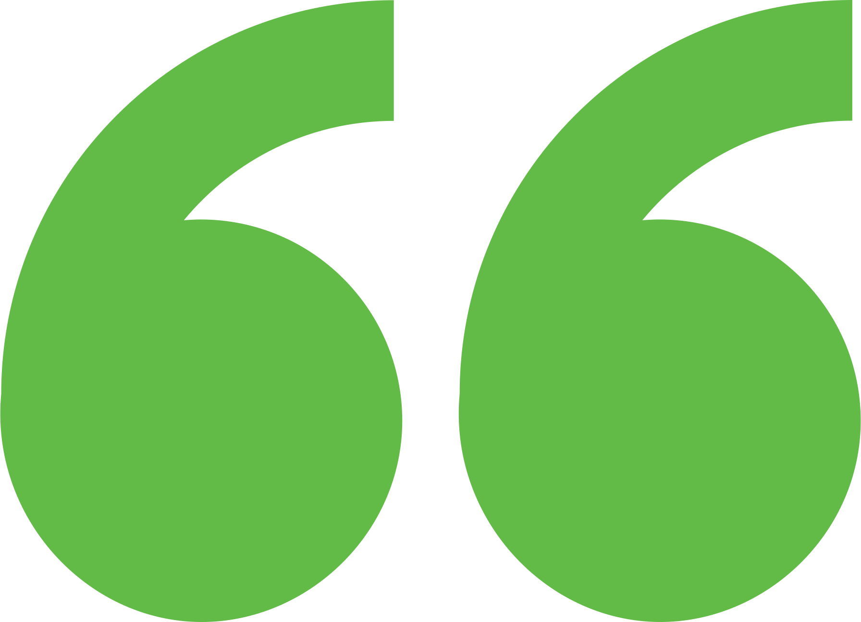 Impact

The insights from this study offered a means to empower property owners to protect their rights and facilitate their access to sustainable and renewable energy alternatives.

Background

Photo goes here.

*Delete this box before publishing.*

**Background**

Ann Arbor is a city of approximately 122,000 people located in southeast Michigan. The city and its residents are leaders in sustainability and climate action. Their A2ZERO Climate Action Plan outlines their just transition pathway to community-wide carbon neutrality by 2030. With equity as a focus, they are implementing strategies to improve home energy efficiency (EE) and electrify appliances. Toward this, the city wants to explore community geothermal heating and cooling to serve a variety of building types including rental and affordable housing. The city has applied to DOE’s Geothermal Heating and Cooling Design and Deployment program and garnered the support of City Council to pursue these projects, but they need to understand the concept’s feasibility in order to make a “go, no-go” decision.

The City of Lawrence is grappling with a pressing issue of deceptive and predatory marketing practices within the solar lease industry. Vulnerable property owners are unwittingly entering into long-term, financially burdensome solar lease contracts, depriving them of federal and state incentives for owning their solar rooftop systems. This issue not only exacerbates their energy burden but also obstructs their transition to cleaner, climate-friendly energy solutions like heat pumps and induction cooktops.

Expert Match Team

**Alexandra Kramer**  
Community Lead, Main Expert Match Point of Contact and Researcher, NREL

**Sika Gadzanku**  
C2C Expert Match Program Manager, NREL

Community Team

**Anil Naval**  
Advisor to the Mayor on Energy, Environment, Sustainability

**Theo Rosario**  
Chief Technology Officer of Public Works

For more information, visit:  
**energy.gov/eere/clean-energy-communities-program**

August 2024